Step 1

Enable-WindowsOptionalFeature -Online -FeatureName Microsoft-Windows-Subsystem-Linux

prateek_linux

linux_19

C:\Users\502616262\.docker\machine\machines\docksal is equivalent to home/prateek_linux/

1. Open ~/.docksal/docksal.env and set DOCKSAL_DNS_UPSTREAM to your local network DNS server

2. Run fin system reset dns to see if it works

clone it in window

docksal.env

site_init

update db name

copy the db from server

place the db inside db local folder

download db from site factory / cloud

place it in C:\Project\bhge-sites\.docksal\local folder

rename the db file name in docksal.env at line 33

run fin project start (run composer, intiate site)

fin site-init

--------------------------------

open ubuntu

first do fin system start

than do cd /c

than do ls -la

than only you can see Project folder

fin system start shows any error than you need to reset dns

do

vi ~/.docksal/docksal.env

save these 2 lines in the file

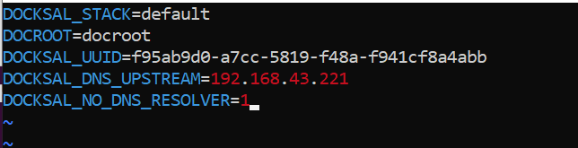

Than do :wq to save and quit the file.

fin init

import config

prateek_linux@GF1HQ8S2E:/c/Project/bhge-sites/source/drupal$ fin drush @ge.local cim

fin project remove

C:\Users\502616262\AppData\Local\Packages\CanonicalGroupLimited.Ubuntu18.04onWindows_79rhkp1fndgsc\LocalState\rootfs

https://docs.docksal.io/fin/fin-help/

fin system reset dns

fin vm restart

disbale module

fin drush pmu simplesamlphp_auth -y

rebuil cache

fin drush @ge.local cr

fin project stop (should be in project folder)

fin system stop